Newton's laws of motion are of fundamental importance in classical physics. Newton gave three laws connected with motion and are, popularly, known as Newton’s laws of motion.

(a) First Law (Law of Inertia)
Everybody continues in its state of rest or of uniform motion in a straight line unless it is compelled by some external force to change that state.
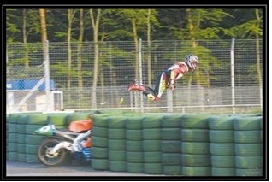

(b) Second Law
The rate of change of momentum of a body is directly proportional to the impressed force and takes place in the direction of the force.
So, F= dp/dt
This results force acting a body F is equal to the mass of the body m times acceleration of the body a.
So, F = ma
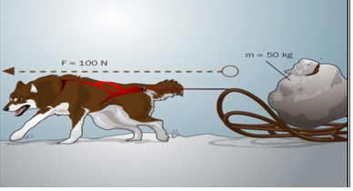

(c)Third Law
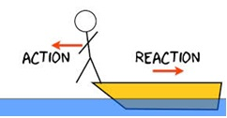
To Every action there is an equal and opposite reaction.
F_{AB} = - F_{BA}
The first two laws relate to the type of motion of a system that results from a given set of forces. The third law studies the basic nature of all forces i.e. they act in action - reaction pair.
"Newton's laws of Motion" is one of the easiest and important chapters of Mechanics in the Physics syllabus of IIT JEE, AIEEE and other engineering examinations. These laws are not new to any aspirant as he is using these laws even in previous classes. The examples based on this are very easy and can be seen even in day to day life.
The chapter is important not only because it fetches 2-3 questions in most of the engineering examination but also because it is prerequisite to the other chapters of Mechanics.

Types of Forces
If we want to produce motion in a body, already at rest, or if we want to destroy the motion of a moving body, we have to apply ‘effort’ known as force in the form of a pull or push.

Force:-
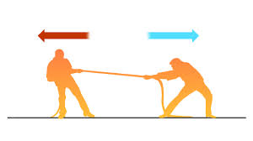
Force is defined as that pull or push which produces or tends to produce, destroys or tends to destroy motion in a body, increases or decreases the speed of the body or changes its direction ofmotion. Therefore, “Force" is an external or internal agent present to "influence" the natural state of motion of an object. Thus, this is an influence (force) needed to change the natural state of body; that is of rest or of uniform motion.
Force is the basic cause of motion.

Classification of Forces:-
There are different types of forces in our universe. Based on the nature of the interaction between two bodies, forces can be classified into two main categories.

(a) Contact Forces:-
These are the forces which come into play due to actual contact between the sources and the object. Basically, it is the force that act between the bodies in contact with each other. For example, Normal Reaction, Friction etc.

(i) Tensional Force (T):-
When a string, thread or wire is held taut, the ends of the string or thread (or wire) pull on whatever bodies are attached to them in the direction of the string. This force is known as Tension.
If the string is massless, then the tension T has the same magnitude at all points throughout the string.
The direction of tension is always from the point of attachment to the body.
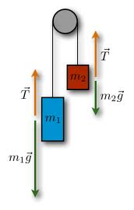

(ii) Spring Force:-
Force in an extended (or compressed) spring is proportional to the magnitude of extension (or compression).
i.e. F α x, in magnitude, but opposite in direction.
So, F = -kx, where k is a positive constant, also known as the spring constant of the spring; and x is the compression or elongation from the natural length.
(iii) Normal reaction:-
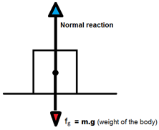
When a body exerts a force on another, the second provides a reaction which acts perpendicular to the surface of 2nd body.
(iv) Friction:-
It is a force that acts between bodies in contact with each other along the surface of contact and it opposes relative motion (or tendency of relative motion) between the two bodies.
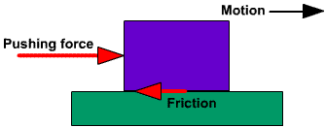
(v) Air Resistance (F_{a}):-
Applicable when motion takes place through air. This force becomes appreciable for bodies moving at high speeds.
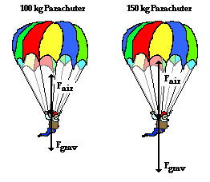
(vi) Weight (W):-
It is a field force, the force with which a body is pulled towards the center of the earth due to its gravity. It has the magnitude mg, where m is the mass of the body and g is the acceleration due to gravity.
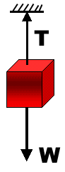

(b) Non-Contact Forces (Field Forces or Action at a Distance Forces):-
Forces which come into existence without any physical contact between the bodies. These forces are due to some inherent characteristics of the body.
Forces that act between bodies separated by a distance without any actual contact. For example, Tension, Spring, Weight etc.
Examples:-
(i) Gravitational Forces (F_{g}):- This is due to the gravitation attraction between two bodies. If we deal with cases of attraction due to earth, this force is always directed downwards.
(ii) Electrical Forces (F_{elec}):- These forces are due to the charges present on the two bodies. The direction of these forces depends upon the type of charges on the two interacting bodies.
(iii) Magnetic Forces (F_{mag}):- Forces which come into play between two bodies due to their magnetic characteristics. Their direction also depends upon the nature of magnetic polarity acquired by the body.

Newton’s First Law of Motion
To study Newton’s first law of motion, the concept of equilibrium should be clear to us. Whenever a number of forces act on a body and they neutralize each other’s effect, the body is said to be in equilibrium. In such a case there is no change in the state of rest or of motion. If however, the system of forces have a resultant, the state of rest or that of motion undergoes a change. This isexplained by Newton’s first law of motion.
It states that,” Every body continues in its state of rest or of uniform motion in a straight line unless it is compelled by some external force to change that state. Therefore, every object persists in its natural state of motion i.e. continues to be at rest or moves in a straight line with uniform (constant) velocity, in the absence of a net external force acting (impressed) on it.
It can be easily deduced from the statement of change in the state of motion. It is directly related to a frame of reference about which we have discussed earlier. To mark the point here, we can discover that by viewing objects from different frame of references the natural state of motion as perceived by different observers will be obviously different (can only be same if the frames are truly equivalent). Therefore, the change in state will also depend on the choice of reference frame. Finally, the amount of acceleration produced in a body (or change in velocity) will depend on our choice of reference frames.

Law of Inertia
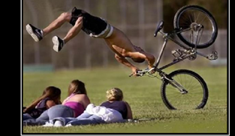
Inertia is the property of all bodies by virtue of which they are unable to change their state of rest or of uniform motion in a straight line without the help of an external force. In other words inertia can also be termed as a resistance to change the state of motion of a body.
Inertia can be classified into following three categories.

(a) Inertia of Rest:-
It is the property of a body by virtue of which it is unable to change its state of rest without the help of an external force.

(b) Inertia of Motion:-
It is the property of a body by virtue of which it is not able to change its speed without the help of an external force.

(c) Inertia of Direction:-
It is the property of a body by virtue of which it is unable to change its direction of motion without the help of an external force.
Qualitative definition of force from first law:-
Newton’s first law states that there cannot be any change in the state of rest or that of motion of a body unless some external force acts upon it. In other words force is an agent which is capable of producing any change in state of rest or that of motion (including direction). This provides a qualitative definition of force.

Some Conceptual Questions

Question 1:-
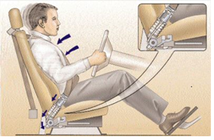
A car moving at constant speed is suddenly braked. The occupants, all wearing seat belts, are thrown forward. The instant the car stops, however, the occupants are all jerked backward. Why? Is it possible to stop an automobile without this ‘jerk’?

Solution:-
Newton’s first law states that, without any external force, if a body is at rest, it will remain at rest and if the body is moving with constant velocity, it will continue to do so. When the car is suddenly braked, due to the inertia, the occupants in the car will tend to move in the forward direction of car. When the car stops the sit belt in the car will produce backward momentum on the occupants. Since the all the occupants wearing seat belts, therefore the occupants are all jerked backward.
Yes, it is possible to stop an automobile without this jerk. This can be done by slowing down the car a little longer time.

Question 2:-
Why do you fall forward when a moving bus decelerates to a stop and fall backward when it accelerates from rest? Subway standees often find it convenient to face the side of the car when the train is starting or stopping and to face the front or rear when it is running at constant speed. Why?

Solution:-
Newton’s first law states that, without any external force, if a body is at rest, it will remain at rest and if the body is moving with constant velocity, it will continue to do so.
When the moving bus decelerates, due to inertia, the body will tend to move in the forward direction of the bus. Therefore, you fall forward when the moving bus decelerates to a stop. Again, when the bus accelerates from rest, due to inertia, the body will tend to maintain the rest position. That is why; you fall backward when the bus accelerates from rest.
The tendency of a body to remain at rest or in uniform linear motion is called inertia. The reference frame to which it applies is called inertial frames. When the train is starting or stopping, there is no net force acting on the observer. So the observer is in the inertial frame. That is why; it is easy to face the side of the car because both the frame (one is observer in the car and the other one is the outside of the car) are in rest. But when the car is running at constant speed, the observer in the car does not remain at rest. The frame is not an inertial frame. That is why; it is easy to face the front or rear when the car is running at constant speed because the car is in the forward direction.

Question 3:-
A mass 'M' is lying (figure shown below) on a table which is at rest (w.r.t. the table on which it is kept). Explain its state with the help of Newton's First Law of motion.
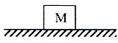

Solution:-
Since 'M' is lying on a table, there is no external force acting on it (forget about gravity just for the immediate discussion). As per Newton's first law of motion it will keep on lying at rest with respect to table for infinite time.
Here, comes out a very important, intrinsic (that is inherent) property of a body which is that it retains its state of motionlessness (as well as of motion, if it is in motion) which is termed as INERTIA of an object. This is present in all materialistic bodies in this universe.

Newton’s Second Law of Motion

Momentum
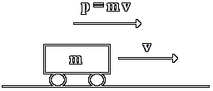
Momentum of a body is defined as the amount of motion contained in a body.
Quantity of motion or the momentum of the body depends upon,
(a) mass of the body.
(b) velocity of the body.
Therefore momentum of a body of mass ‘m’ and velocity ‘v’ will be,

Definition of Quantitative
Momentum of a body is equal to the product of its mass and velocity. Momentum is a vector quantity and possesses the direction of velocity.
Units:-
S.I:- kg m s⁻¹
C.G.S:- g cm s⁻¹
Momentum can be put into following two categories.
Dimension:-
[MLT⁻¹]

(a) Non-Relativistic Momentum
According to classical physics (or non-relativistic physics) which is based upon the concepts of Newton’s laws of motion, mass of a body is considered to be a constant quantity, independent of the velocity of body. In that case momentum is given by,
.
Thus, momentum of a body is a linear function of its velocity.

(b) Relativistic Momentum
In accordance to Einstein’s special theory of relativity, mass of a body depends upon the relative velocity ‘v’ of the body with respect to the observer. If ‘m₀’ is the mass of body observed by an observer at rest with respect to body, its relativistic mass ‘m’ is given by,
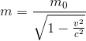
Therefore, momentum of a body according to the concepts of theory of relativity is given by,
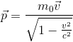
Thus, relativistic momentum is not a linear function of v.

Frame of Reference
A system of co-ordinates whose axes can be suitably chosen is said to be a frame of reference. For location of a point ‘P’ we need three co-ordinate x, y and z. For complete identification of an event we must know ‘t’ also, i.e., the time of the occurrence. Hence an event in characterized by four co-ordinates (x,y,z,t). A reference frame describing an event in these four co-ordinates is known a space time frame.
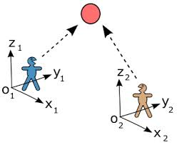

Inertial and Non-Inertial Frame of Reference
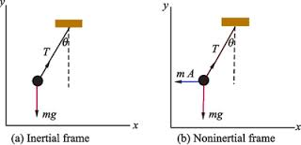

(a) Inertial Frame
A frame of reference either at rest or moving with a uniform velocity (zero acceleration) is known as inertial frame. All the laws of physics hold good in such a frame.
An inertial frame is endowed with the following characteristics:
(i) All the fundamental laws of physics are valid in inertial frames.
(ii) All the fundamental laws of physics assume the same mathematical shape in all inertial frames.
(iii) They are isotopic with respect to mechanical and optical experiments

(b) Non-Inertial or Accelerated Frame

It is a frame of reference which is either having a uniform linear acceleration or is being rotated with uniform speed.

Newton’s Second Law
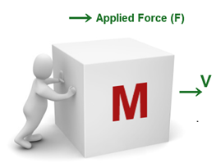
The rate of change of momentum of a body is directly proportional to the impressed force and takes place in the direction of the force.
Newton’s first law provides a qualitative definition of the force while second law provides a quantitative definition of the force.
Let be the instantaneous velocity of the body. Momentum of the body is given by,
According to second law,
∝ (rate of change of momentum)
Or,
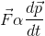
Or,
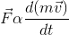
Or,
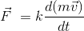
Here ‘k’ is the constant of proportionality. Mass ‘m’ of a body is considered to be a constant quantity.
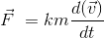
or,
The units of force are also selected that ‘k’ becomes one.
Thus, if a unit force is chosen to be the force which produces a unit acceleration in a unit mass,
i.e., F = 1, m = 1 and a = 1.
Then, k = 1
So, Newton’s second law can be written , in mathematical form, as
i.e., Force = (mass) (acceleration)
This provides us a measure of the force.
Here, if F = 0 then we find a = 0. This reminds us of first law of motion. That is, if net external force is absent, then there will be no change in state of motion, that means its acceleration is zero.
Further we can extend second law of motion, (in fact its decomposition) to three mutually perpendicular directions as per our coordinate system.
If components in x, y and z direction are F_{x}, F_{y} & F_{z} respectively, the three acceleration produced when F_{x}, F_{y} & F_{z} act simultaneously) in the body are, Now,
If we add three forces then resultant is called net external force.
Similarly,
is called net acceleration produced in the body.
Unit of Force:-
S.I:- Newton [kg.m/sec²]
C.G.S:- Dyne [g.cm/sec²]
Dimension:-
[MLT⁻²]

Impulse
Impulse of a force is defined as the change in momentum produced by the force and it is equal to the product of force and the time for which it acts. Therefore, a large force acting for a short time to produce a finite change in momentum which is called impulse of this force and the force acted is called impulsive force or force of impulse.
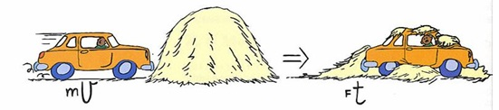

According to Newton’s second law of motion,
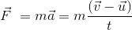
or,
So, Impulse of a force = change in momentum.
If the force acts for a small duration of time, the force is called impulsive force.
As force is a variable quantity, thus impulse will be,
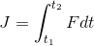
The area under F - t curve gives the magnitude of impulse.
Impulse is a vector quantity and its direction is same as the direction of .
Unit of Impulse:- The unit in S.I. system is kgm/sec or newton -second.
Dimension:- MLT¹

Problem 1:-
The Sun yacht Diana, designed to negative in the solar system using the pressure of the sunlight, has a sail area of 3.1 km² and a mass of 930 kg. Near Earth’s orbit, the sun could exert a radiation force of 29 N on its sail. (a) What acceleration would such a force impart to the craft? (b) A small acceleration can produce large effects if it acts steadily for a long enough time. Starting from rest then, how far would the craft have moved after 1 day under these conditions? (c) What would then be its speed? (See “The Wind from the Sun,” a fascinating science fiction account by Arthur C.Clarke of a Sun yacht race.)

Solution:-
(a)
Given Data:-
Mass of the yacht Diana, m = 930 kg
Force exerted by the sun light, F = 29 N
Force acting on the body (F) is equal to the product of mas of the body (m) and acceleration of the body (a).
So, F = ma …… (1)
From equation (1), the acceleration (a) of the body would be,
a = F/m …… (2)
Putting the value of m and a in equation (2), the acceleration such force impart to the craft would be,
a = F/m
= 29 N /930 kg
= (3.1×10⁻² N/kg) (1 kg. m/s² /1 N)
= 3.1×10⁻² m/s² …… (3)
Thus acceleration such force impart to the craft would be, 3.1×10⁻² m/s².
(b)
Given Data:-
Time, t = 1 day
= (1day) (24 h/1 day) (60 min/1 h) (60 s/1 min)
= 86400 s
Initial velocity, v_{i} = 0
Acceleration, a = 3.1×10⁻² m/s²
From equation of motion, we know that,
Distance travelled by the body (x) = v_{i} + ½ at²
So, x = v_{i}t+ ½ at² …… (4)
Putting the value of v_{i}, a and t in equation (4), the distance travelled by the craft will be,
x = v_{i}t+ ½ at²
= 0+½ (3.1×10⁻² m/s²) (86400 s)² (Since, a = 3.1×10⁻² m/s² and t = 86400 s)
=1.1571×10⁸ …… (5)
Rounding off to two significant figures, the distance will be 1.2×10⁸ m.
Thus from the above observation we conclude that, the craft have moved1.2×10⁸ m after 1 day under these conditions.
(c)
Given data:
Acceleration, a = 3.1×10⁻² m/s²
Time, t = 86400 s
Acceleration of an object is equal to the velocity of the object divided by time.
a = v/t
So, v = at ……(6)
Putting the value of a and t in equation (6), velocity would be,
v = at
= (3.1×10⁻² m/s²) (86400 s)
= 2678.4 m/s
Rounding off to two significant figures, speed will be 2700 m/s.
Thus from the above observation we conclude that, speed will be 2700 m/s.

Problem 2:-
A car travelling at 53 km/h hits a bridge abutment. A passenger in the car moves forward a distance of 65 cm (with respect to the road) while being brought to rest by an inflated air bag. What force (assumed constant) acts on the passenger’s upper torso, which has a mass of 39 kg?

Concept:-
Force acting (F) on the body is equal to the mass of the body (m) times deceleration of the body (a).
F = ma …… (1)

Solution:-
First we have to find out the deceleration (a) of the car.
If v₀ is the initial speed of car and v is the final speed of the car, then the average speed (v_{av}) of the car will be,
v_{av,} = ½ (v+ v₀) …… (2)
To obtain the average speed (v_{av}) while the car is decelerating, substitute 53 km/h for v₀ and 0 m/s for v in the equation v_{av} = ½ (v+ v₀),
v_{av} = ½ (v+ v₀)
= ½ ((53 km/h)+ (0 m/s))
= (½ ×53 km/h) (1,000 m/1 km) (1 h/60 min) (1 min/60 s)
= 7.4 m/s …… (3)
But average speed (v_{av}) is equal to the rate of change of displacement (x).
v_{av} = x/ t
So, t = x/ v_{av} …… (4)
To obtain the time of deceleration t, substitute 0.65 m for x and 7.4 m/s for v_{av} in the equation t = x/ v_{av},
t = x/ v_{av}
= 0.65 m /7.4 m/s
= 8.8×10⁻² s …… (5)
Deceleration (a) is equal to rate of change of velocity.
So, a = Δ v /t
= ((0) - (53 km/h))/ 8.8×10⁻² s
= (-53 km/h)/ 8.8×10⁻² s
= ((-53 km/h) (1,000 m/1 km) (1 h/60 min) (1 min/60 s))/ 8.8×10⁻² s
= (-14.7 m/s)/ (8.8×10⁻² s)
= -1.7×10² m/s² ……(6)
To obtain the force (F) acting on the passengers upper torso having mass 39 kg, substitute 39 kg for mass m and -1.7×10² m/s² for decelerationa in the equation, F = ma,
F = ma
= (39 kg) (-1.7×10² m/s²)
= -6630 kg. m/s²
= -(6630 kg. m/s²) (1 N/1 kg. m/s²)
= -6630 N …… (7)
Rounding off to two significant figures, the magnitude of the force will be 6600 N.

Problem 3:-
Workers are loading equipment into a freight elevator at the top floor of a building. However, they overload the elevator and the worn cable snaps. The mass of the loaded elevatorat the time of the accident is 1600 kg. As the elevator falls, the guide rails exert a constant retarding force of 3700 N on the elevator. At what speed does the elevator hit the bottom of the shaft 72 m below?

Concept:-
Force acting on the body (F) is equal to the product of mas of the body (m) and acceleration of the body (a).
So, F = ma
From equation F = ma, the acceleration (a) of the body would be,
a = F/m
Weight W of the object is equal to the mass m of the object times of the free fall acceleration g.
W = mg
In accordance to equation of motion, the distance y travelled by the body will be,
y = ut + ½ at²
Here u is the initial velocity, t is the time, and a is the acceleration.
When the elevator falls, the initial velocity u will be equal to zero.
So, u = 0
Substitute 0 for u in the equation y = ut + ½ at²,
y = ut + ½ at²
= 0×t +½ at²
= ½ at²
So the time t will be,
t = √2y/a
Speed v is equal to the product of acceleration a of the body and time t.
So, v = at

Solution:-
To obtain the weight of the elevator W, substitute 1600 kg for mass of the elevator m and 9.81 m/s² for free fall acceleration g in the equationW = (m) (g),
W = (m) (g)
= (1600 kg) (9.81 m/s²)
=15680 kg,m/s²
= (15680 kg,m/s²) (1 N/1 kg,m/s²)
= 15680 N
The magnitude of the net force F will be,
F = W-R
To obtain the magnitude of the net force F, substitute 15680 N for W and 3700 N for retarding force R in the equation F = W-R,
F = W-R
= (15680 N) – (3700 N)
=11980 N
Rounding off to two significant figures, the magnitude of the net force F will be 12000 N.
To obtain the acceleration a, substitute 12000 N for F and 1600 kg for m in the equation a = F/m, we get,
a = F/m
= 12000 N/1600 kg
= (7.5 N/kg) (1 kg.m/s²/1 N)
= 7.5 m/s²
To obtain the time t to fall, substitute -72 m for y and -7.5 m/s² for a in the equation t = √2y/a,
t = √2y/a
= √2(-72 m) /(-7.5 m/s²)
= 4.4 s
To obtain the final speed v at which the elevator hits the bottom of the shaft 72 m below, substitute 7.5 m/s² (only magnitude of a) for a and 4.4 s for t in the equation v = at, we get,
v = at
= (7.5 m/s²) (4.4 s)
= 33 m/s
From the above observation we conclude that, the speed at which the elevator hits the bottom of the shaft 72 m below would be 33 m/s.

Newton’s Third Law of Motion
It states that,
“To every action there is an equal and opposite reaction”.
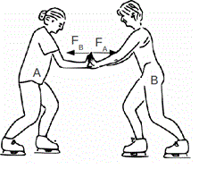
Whenever one force acts on a body, it gives rise to another force called reaction. A single isolated force is an impossibility. The two forces involved in any interaction between two bodies are called “action” and “reaction”. But this does not imply any difference in their nature, or that one force is the ‘cause‘ and the other is the ‘effect’. Either force may be considered as ‘action’ and the other ‘reaction’ to it.
It may be noted that action and reaction never act on same body.
Note: The most important fact to notice here is that these oppositely directed equal action and reaction can never balance or cancel each other because they always act, on two different point (broadly on two different objects) For balancing any two forces the first requirement is that they should act one and the same object. (or point, if object can be treated as a point mass, which is a common practice)

Simulation for Newton's Third Law

Few Examples on Newton’s third Law of Motion
(a) Book Kept on a Table
A book lying on a table exerts a force on the table which is equal to the weight of the book. This is the force of action. The table supports the book, by exerting an equal force on the book. This is the force of reaction, as shown in the below figure. As the system is at rest, net force on it is zero. Therefore, forces of action and reaction must be equal and opposite.
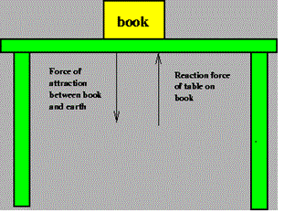
(b) Walking on the ground:-
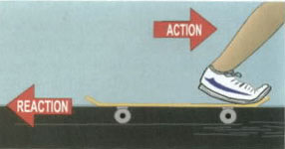
While walking a person presses the ground in the backward direction (action) by his feet. The ground pushes the person in forward direction with an equal force (reaction). The component of reaction in the horizontal direction makes the person move forward.
(c) Process of Swimming:-
A swimmer pushes the water backwards (action). The water pushed the swimmer forward (reaction) with the same force. Hence the swimmer swims.
(d) Firing from a gun:-
When a gun is fired, the bullet moves forward (action). The gun recoils backwards (reaction).
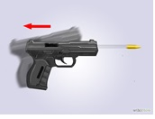
(e) Fight of jet planes and rockets:-
The burnt fuel which appears in the form of hot and highly compressed gases escapes through the nozzle (action) in the backward direction. The escaping gases push the jet plane or rocket forward (reaction) with the same force, hence, the jet or rocket moves.
(f) Rubber ball re-bounds from a wall:-
When a rubber ball is struck against a wall or floor it exerts a force on a wall (action). The ball rebounds with an equal force (reaction) exerted by the wall or floor on the ball.
(g) It is difficult to walk on sand or ice:-
This is because on pushing, sand gets displaced and reaction from sandy ground is very little. In case of ice, force of reaction is again small because friction between feet and ice is very small.
(h) Driving a nail in to a wooden block without holding the block is difficult:-
This is because when the wooden block is not resting against a support, the block and nails both move forward on being hit with a hammer. However, when the block is held firmly against a support, and the nail is hit, an equal reaction of the support drives the nail into the block.
(i) A tea cup breaks on falling on the ground:-
Tea cup exerts certain force (action) on ground while the ground exerts an equal and opposite reaction on the cup. Ground is able to withstand the action of cup, but the cup being relatively more delicate breaks due to reaction.

Problem 1:-
Two blocks, with masses m₁ = 4.6 kg and m₂ = 3.8 kg, are connected by a light spring on a horizontal frictionless table. At a certain instant, when m₂ has an acceleration a₂ = 2.6 m/s², (a) what is the force on m₂ and (b) what is the acceleration of m₁?

Concept:-
Force acting on the body (F) is equal to the product of mas of the body (m) and acceleration of the body (a).
So, F = ma
From equation F = ma, the acceleration (a) of the body would be,
a = F/m

Solution:-
(a) The net force ∑ F_{x} on the second box having mass m₂ will be,
∑ F_{x} = m₂a_{2x}
Here a_{2x} is the acceleration of the second block.
To obtain the net force ∑ F_{x} on the second box having mass m₂, substitute 3.8 kg mass m₂ and 2.6 m/s² for a_{2x} in the equation ∑ F_{x} = m₂a_{2x},
∑ F_{x} = m₂a_{2x}
= (3.8 kg) (2.6 m/s²)= 9.9 kg .m/s²
= (9.9 kg .m/s²) (1 N/ 1 kg .m/s²)= 9.9 N
From the above observation we conclude that, the net force ∑ F_{x} on the second box having mass m₂ would be 9.9 N. There is only one (relevant) force on the block, the force of block 1 on block 2.
(b) There is only one (relevant) force on block 1, the force of block 2 on block 1. By Newton’s third law this force has a magnitude of 9.9 N.
So the Newton’s second law gives,
∑ F_{x} = m₁a_{1x} = -9.9 N
But, m₁a_{1x} = (4.6 kg) (a_{1x}) (Since, m₁ = 4.6 kg)
(4.6 kg) (a_{1x}) = -9.9 N
So, a_{1x} = -9.9 N/4.6 kg
= (- 2.2 N/kg) (1 kg.m/s² / 1 N) = -2.2 m/s²
From the above observation we conclude that, the acceleration of m₁ will be -2.2 m/s².
_______________________________________________________________________________________________

Problem 2:-
A meteor of mass 0.25 kg is falling vertically through Earth’s atmosphere with an acceleration of 9.2 m/s². In addition to gravity, a vertical retarding force (due to frictional drag of the atmosphere) acts on the meteor as shown in the below figure. What is the magnitude of this retarding force?
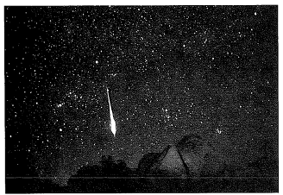

Solution:-
Given Data:
Mass of the meteor, m = 0.25 kg
Acceleration of the meteor, a = 9.2 m/s²
The net force exerted (F_{net}) on the meteor will be,
F_{net} = ma
= (0.25 kg) (9.2 m/s²) = (2.30 kg. m/s²) (1 N/ 1 kg. m/s²) = 2.30 N …… (1)
If g (g = 9.80 m/s²) is the free fall acceleration of meteor, then the weight of the meteor (W) will be,
W = mg = (0.25 kg) (9.80 m/s²)
= (2.45 kg. m/s²) (1 N/ 1 kg. m/s²) = 2.45 N …… (2)
The vertical retarding force would be equal to the net force exerted on the meteor (F_{net}) minus weight of the meteor (W).
So, vertical retarding force = F_{net} –W …… (3)
Putting the value of F_{net} and W in equation (3), the vertical retarding force will be,
Vertical retarding force = F_{net} –W = 2.30 N -2.45 N = -0.15 N ……. (4)
From equation (4) we observed that, magnitude of the vertical retarding force would be, -0.15 N.
_______________________________________________________________________________________________

Problem 3:-

Suppose in figure shown above we put one more block of 5 kg mass adjacent to 10 kg and a force of 150 N acts as shown in the figure below, then find the forces acting on the interface.
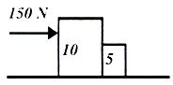

Solution:-
The combined acceleration of the two bodies when treated as one is
a = F/((10+5))=150/15=10/sec²
So each one moves with a = 10m/sec² keeping their contact established.
Here you can feel that due to 150N force the body of 5 kg feels as if it is being pushed by the 10 kg mass. There is force acting on 5kg called R₁, to oppose it by third law this body exerts a force R₂ on 10kg. The interface is as shown in Figure given below.
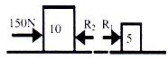
Also, third law tells us that R₁ = R₂ in magnitude and is opposite in direction.
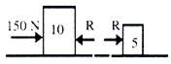
R₁ = R₂ = R
Here since 150 N force acts on the 10kg mass and only r acts on the 5kg mass. For motion in 5kg only R is responsible. We can write the initial equation as:
F = 150 = (10 + 5) a
150 = 10a + 5a
Here 10a is force experienced by 10kg mass. And 5a is experienced by 5kg mass.
R = 5a a = 10m/sec²
So,R = 50N
Thus,Net force experienced by 10kg block is (150-R) = 10a 150-R = 1010 = 100 N
Therefore, R = 50
Therefore we get R = 50N for both blocks. Hence we find "action and reaction are equal and opposite". Now net force on the body of 10kg mass is 100N & Net force on the body of 5kg mass is 50N and on the interface action and reaction are both equal and also are equal to force experienced by second body.
_________________________________________________________________________________________________

Problem 4:-
An object is hung from a spring scale attached to the ceiling of an elevator. The scale reads 65 N when the elevator is standing still. (a) What is the reading when the elevator is moving upward with constant speed of 7.6 m/s? (b) What is the reading of the scale when the elevator is moving upward with a speed of 7.6 m/s and decelerating at 2.4 m/s²?

Solution:-
Weight of the object (W) when the elevator is standing, W = 65 N
(a) We have to find out the scale reading when the elevator is moving upward with a constant speed of 7.6 m/s.
Since the elevator is moving upward with a constant speed, therefore there is no acceleration of the system resulting there is no force. Thus the scale reading must be equal to the weight of the object and that will be 65 N.
(b) We have to find out the scale reading when the elevator is moving upward with a speed of 7.6 m/s and decelerating at 2.4 m/s².
The force exerted on the object due to the deceleration at the rate 2.4 m/s² (a = - 2.4 m/s²) will be,
F = ma
= (W/g) a …… (1)
Where W is the weight of the object (W = 65 N) when the elevator is at rest and g is the free fall acceleration of the object (g=9.80 m/s²).
Putting the value of W, g and a in equation (1) the force exerted on the object will be,
F = (W/g) a
= (65 N/9.80 m/s²) (-2.4 m/s²)
= -15.92 N
= -16 N …… (2) (Rounding off to two significant figure)
When the elevator is moving upward with a speed of 7.6 m/s and decelerating at 2.4 m/s², the force would be,
= F- (-W)
= -16 N –(-65 N)
= -16 N+65 N
= 49 N …… (3)
From the above observation we conclude that, the scale reading when the elevator is moving upward with a speed of 7.6 m/s and decelerating at 2.4 m/s² would be 49 N.

Frame of Reference
A system of co-ordinates whose axes can be suitably chosen is said to be a frame of reference. For location of a point ‘P’ we need three co-ordinate x, y and z. For complete identification of an event we must know ‘t’ also, i.e., the time of the occurrence. Hence an event in characterized by four co-ordinates (x,y,z,t). A reference frame describing an event in these four co-ordinates is known a space time frame.

Inertial and Non-Inertial Frame of Reference
In general we solve the problem of mechanics using inertial frame, which was discussed in chapter two, but as the same time it is possible to solve the same problem using a non-inertial frame. Let us discuss about the difference between these frames.
When Newton stated his first law he made a very important distinction. He decreed the absolute equivalence between a state of rest and one f uniform motion and distinguished it specifically and absolutely from that of an accelerated motion. If the environment is completely symmetric then no direction is preferred over another and therefore if a body possesses a initial velocity (which might be zero) it will persist with that velocity. If suppose we say that the velocity will change then we will have to concede that the velocity changes in a particular direction. But why should it change in one direction and not in the other, since all direction are equally favored. So the only way it can change is to change in all directions. But this is impossible so it will not change at all, i.e. if environment is really symmetric. Therefore if we grant a change in velocity we will also have to grant an irregularity in the environment in the same direction as the change in velocity. The acceleration, he said to be understood as an irregularity and he expressed force as that basic asymmetry in the environment which produces this irregularity. The most important aspect in all this is that force is theoretical construction to explain away the irregularities in motion and is not to be understood as a tangible entity.
Now, for constant mass system
If force is a tangible entity then the force in all systems on the same body should be same. Let us see if this is true.
Consider a body of mass m. We will observe its motion from three different frames.

Simulation for Frame of Reference

(i) Reference frame is at rest:-
The acceleration of the mass will be, say, .
Therefore the force on it will be .
We will reason that
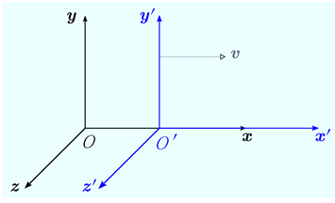
(ii) Reference frame starts moving with constant velocity vector-v :-
The acceleration of frame =
Thus, acceleration of mass m relative to frame is given by
Force on it will be inertial and we will reason that
(iii) Reference frame moves with constant acceleration:-
Let the acceleration of frame be .
Thus, acceleration of mass relative to frame will be .
Let there be force frame on mass we will reason, that
We see that the force is not the same as that in the inertial frames.
Therefore we postulate that under observation from an accelerated reference frame we substitute the inertial forces on the body with those same initial forces plus an additional force which numerically equal to the mass of the body under observation times the acceleration of the frame taken in the opposite direction. This force we call as pseudo force.
Now, we can work on a problem from an accelerated reference frame by just adding a pseudo force and pretending that nothing has changed.
Let us illustrate our point.
(a) Inertial Frame:-
A frame of reference either at rest or moving with a uniform velocity (zero acceleration) is known as inertial frame. All the laws of physics hold good in such a frame.
(b) Non-Inertial or Accelerated Frame:-
It is a frame of reference which is either having a uniform linear acceleration or is being rotated with uniform speed.


An inertial frame is endowed with the following characteristics:
- All the fundamental laws of physics are valid in inertial frames.
- All the fundamental laws of physics assume the same mathematical shape in all inertial frames.
- Inertial frames are isotopic with respect to mechanical and optical experiments
- The optical experiments performed in an inertial frame in any direction will always yield the same results.
Is earth an inertial frame of reference?
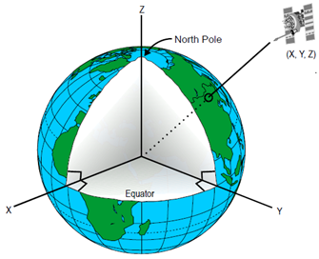
Earth rotates around its axis as also revolves around the sun. In both these motion, centripetal acceleration is present. Therefore, strictly speaking earth or any frame of reference fixed on earth cannot be taken as an inertial fame. However, as we are dealing with speeds ≈ x 10⁸ ms⁻¹ (speed of light) and speed of earth is only about 3 x 10⁴ m/s, therefore when small time intervals are involved effect of rotation and revolution of earth can be ignored. Furthermore, this speed of earth can be assumed to be constant. Hence earth or any other frame of reference set up on earth can be taken as an approximately inertial frame of reference.
On the contrary, a frame of reference which is accelerated or decelerated is a non-inertial frame.
Other examples of inertial frames of reference are:
(i) A frame of reference remaining fixed w.r.t. stars.
(ii) A space ship moving in outer space, without spinning and with its engine cut off.
Apparent weight of a man inside a lift:-
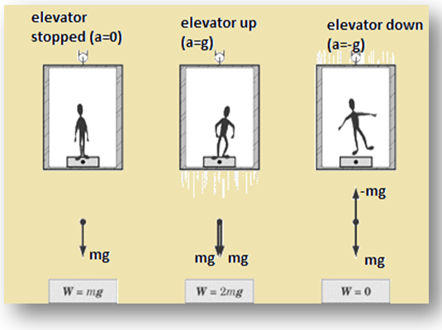
(a) The lift possesses zero acceleration (fig-1): W = mg
(b) The lift moving upward with an acceleration a (fig-2):
W = mg + ma
= mg + mg
= 2 mg
(c) The lift moving downward with an acceleration a (fig-3):
W = mg – ma
= mg – mg
= 0

Conceptual Problem
Problem 1:-
Suppose that you are standing on the balcony of a tall tower, facing east. You drop an object so that it falls to the ground below; see below figure. Suppose also that you can locate the impact point very precisely. Will the object strike the ground at a, vertically below the release point, at b to the east, or at c to the west? The object was released from rest; the Earth rotates from west to east.
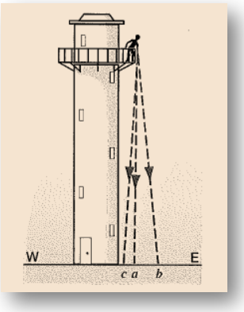
Solution:-
If one assumes that the factor by which the Earth rotates is negligible during the time the object takes to reach the ground, then the object will hit the ground at point a and one will not have to concern about the Carioles Effect.
In case the factor is non-negligible, and the Earth moves from West to East, the object will hit the ground at point c. The situation is similar to the perceived leftward displacement of the air moving to a low pressure point from north to south. To the person standing on the balcony of a tall tower, a psuedo force has acted on the object in a direction from east to west.
____________________________________________________________________________________________________
Problem 2:-
What is the distinction between inertial reference frames and those differing only by a translation or rotation of the axes?
Solution:-
One can distinguish the inertial frame of reference against the translation of the axes when the translation or rotation occurs non-uniformly.
If the translation of one frame of reference relative to the other is such that observer in one frame measures some acceleration of the other, then the observer can draw a distinction between his frame and the inertial frame of reference.
It is important to note that the rotating frame will always be non-inertial because to account for the rotation there must be a change in velocity vector. Therefore the inertial reference frame will always be distinct from the rotation frame.
However the translation can be distinguished from the inertial frame of reference only when the translation occurs at a uniform velocity.
_____________________________________________________________________________________________________
Problem 3:-
A passenger in the front seat of a car finds himself sliding toward the door as the driver makes a sudden left turn. Describe the forces on the passenger and on the car at this instant if the motion is viewed from a reference frame (a) attached to the Earth and (b) attached to the car.
Solution:-
(a) From the reference frame attached to the Earth, when the car takes a left turn, the inertia of the passenger would maintain the state of motion of the passenger (in accordance with Newton’s first law of motion). This causes the passenger to move in the direction of velocity vector of car before car took a turn.
Therefore, to the observer at Earth frame, the passenger has the initial velocity equal to the velocity of the car before it takes the turn. The observer also see the car taking a turn, and accounts for an acceleration for the same. Thus, the observer would expect frictional forces to exist between the passenger and the seat.
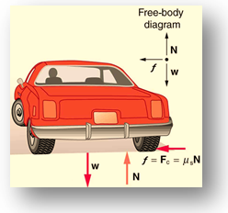
Given that the passenger has moved towards the door when the car took a left turn, it is obvious that the passenger moves to the right. Therefore the frictional force would be in a direction opposite to the motion of the passenger, that is, towards the left.
If you assume that the frictional force between the passenger and seat is given by f , mass of passenger by m whereas the acceleration by a. Then the equation depicting the motion of passenger relative to the observer in Earth’s frame is:
f = ma
Therefore the magnitude of frictional force between the passenger and the seat is equal to the magnitude of the deceleration of the passenger.
(b) According to the observer in car’s frame, the car experiences a centripetal acceleration when it turns to left. Therefore a psuedo force will act on the passenger, accelerating him in the direction of the seat. But there is a friction between the seat of the car and the passenger, which decelerate the passenger in a direction opposite to the direction of its motion.
Thus the magnitude of net force acting on the passenger is the difference between magnitude the centrifugal force and magnitude the frictional force.
If you assume that the centrifugal force acting on passenger is F, the frictional force between the passenger and the seat is f , the mass of passenger is m whereas the acceleration is a. Then the equation depicting the motion of passenger relative to the observer in car’s frame is:
F – f = ma
Therefore one can see that the perceived acceleration for the observer in car differs from that of the observer on Earth.
__________________________________________________________________________________________________
Problem 4:-
Do you have to be concerned with the carioles effect when playing tennis or golf? If not, why not?
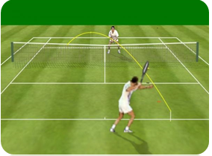
Solution:-
No, one does not have to concern with the Carioles Effect when playing tennis or golf because the factor by which the Earth rotates during the time the ball goes from its source to the destination, is very small and can be neglected. Therefore the player can take his/her shot as if the destination of the ball would be at the same position as it was at the time the shot was taken.

Question 1:-
A reference frame attached to the earth:
(a) is an inertial frame by definition
(b) cannot be an inertial frame because earth is revolving round the sun
(c) is an inertial frame because Newton’s law are applicable
(d) cannot be an inertial frame because the earth is rotating about its own axis.
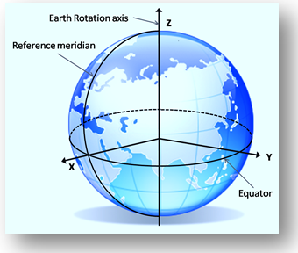
Question 2:-
Which of the following will not depend on orientation of frame of reference:
(a) a scalar
(b) a vector
(c) the magnitude of a vector
(d) component of a vector
Question 3:-
A vector does not change if :
(a) frame of reference is translated
(b) frame of reference is rotated
(c) vector is translated parallel to itself
(d) vector is rotated through an angle other than multiple of 2π.
Question 4:-
A boy sitting in a moving train throws a ball straight up into the air. The ball falls behind him. So the train is
(a) ascending a hill at constant velocity
(b) descending a hill at constant velocity
(c) having accelerated motion
(d) having retarded motion

Q.1 | Q.2 | Q.3 | Q.4
b,d | a,b,c | a,b,c | c

Friction
Whenever the surface of a body slides over another, each body experiences a contact force which always opposes the relative motion between the surfaces. This contact force is called frictional force. Intermolecular interaction arising due to elastic properties of matter is the cause of frictional force.This force acts tangentially to the interface of two bodies.

Cause of Friction
Old view:-
Earlier it was thought that roughness of the two surfaces causes friction in the figure because it can be easily seen that smoother the surfaces, lesser is the friction. Interlocking of irregularities of the two surfaces causes hindrance to sliding. This, however, is not the current view.
Current view:-
The current view is a slight deviation from the old view. Earlier we thought that interlocking of irregularities of surfaces was causing friction. Now, it is though that due to irregularities, the common surface area which is in actual contact of the two surfaces, is much less than the total overall area in contact. In one experiment, it came out to be 1/10,000th of the apparent area.
Thus, while the total interactive (action and reaction) forces between the two surfaces remain the same, the pressures at the points of contact are extremely high and cause the humps to flatten out (undergoing plastic deformation) until the increased area of contact enables the upper solid to be supported. It is thought that at the points of contact, small, cold-welded joints are formed by the strong adhesive forces between molecules which are very close together. These have to be broken away before one surface can move over the other. Thus the force of friction is found to depend upon the following factors.
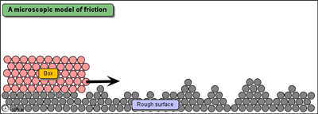
(i) The nature of two surfaces with the surfaces are being pressed together.
(ii) Normal force with the surfaces are being pressed together.
(iii) Actual area of contact

Types of Friction
There are four types of friction.
(a) Static Friction (b) Kinetic Friction (c) Rolling Friction (d) Fluid Friction

(a)Static friction:-
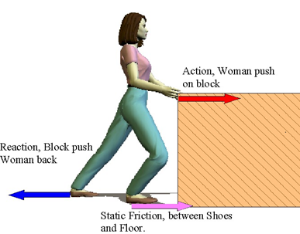
Static friction is the force of friction between two surfaces so long as there is no relative motion between them. It is always equal to the applied force. The static frictional forces are incorporated in the following inequality.
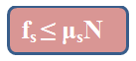
The magnitude of static friction f_{s} (static frictional force) has a maximum value f_{s,max} that is given by,
f_{s,max} = µ_{s}N
Here µ_{s} is the coefficient of kinetic friction and N is the normal force.
So, coefficient of static friction, µ_{s}= f_{s,max} /N
Static friction is always equal to the apllied force. It will be observe that value of static friction increases to certain maximum value, beyond which if the applied force is increased body starts moving. This maximum value of force of friction is called limiting friction.
Limiting friction is the maximum value of force of friction between two surfaces so long as there is no relative motion between them.
(b) Kinetic friction:-
Kinetic friction is the force of friction which comes into play between two surfaces when there is some relative motion between them. The magnitude of force of kinetic friction f_{k} (kinetic frictional force) is proportional to the normal force N.

So,
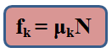
Here µ_{k} is the coefficient of kinetic friction.
Thus, coefficient of kinetic friction, µ_{k} = f_{k}/N

Laws of limiting friction:-
(a) The direction of force of friction is always opposite to the direction of motion.
(b) The force of limiting friction depends upon the nature and state of polish of the surfaces in contact and acts tangentially to the interface between the two surfaces.
(c) The magnitude of limiting friction ‘F’ is directly proportional to the magnitude of the normal reaction R between the two surfaces in contact, i.e.,
F∝R
(d) The magnitude of the limiting friction between two surfaces is independent of the area and shape of the surfaces in contact so long as the normal reaction remains the same.

(c) Rolling friction:-
Force of friction which comes into play, between two surfaces, while one is rolling over the other is called rolling friction. Rolling friction is similar to kinetic friction.
So,
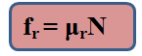
Here µ_{r} is the coefficient of rolling friction and N is the normal force.
(d) Fluid friction:-
Fluid friction is the opposing force which comes into play when a body moves through a fluid.

Cause and Direction of Rolling Friction
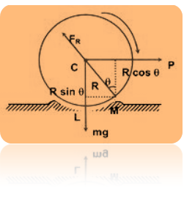
A wheel of radius R rolling without sliding on a flat surface will experience a resistance due to the very small local deformation that takes place, which is sometimes elastic sometimes inelastic, i.e., a kind of ridge is formed in front of the wheel as shown exaggerated in the figure. This gives rise to the force F_{R}, whose line of action passes through the center C of the wheel and P the horizontal force necessary to force the wheel to topple over the point M, the total clockwise torque acting on the wheel about M must be more than or marginally more than the total anticlockwise torque about M.
F = Frictional force
Therefore,
P × R cos θ > mg × R sin θ
P > mg tan θ
The value of "tan θ" is called the coefficient of rolling friction (μ_{g}). This value does not depend upon R. If the two surfaces are absolutely rigid, then no ridge will be formed and q will be zero i.e., coefficient of rolling friction will be zero.
Typical values are μ_{R} = 0.006 for steel and 0.02 - 0.04 for rubber tiers on concrete surfaces. Rolling friction is very small compared to the sliding friction. In case of pure rolling μ_{R} = 0.
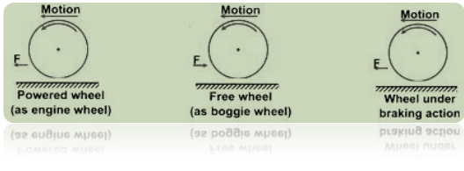
- The value of angle of friction and that of angle of repose are same and the tangents of both of them is equal to the co-efficient of friction.
- When a body slides down an inclined plane, whose angle of inclination with the horizontal is equal to angle of repose, it moves with uniform velocity.
- Sliding friction and rolling friction are independent of velocity.
- Fluid friction depends upon velocity. It increases with an increase in velocity.
- Force of limiting friction does not depend upon the size and shape of surface in contact.
- Coefficient of kinetic friction is less than coefficient of static friction i.e.,µ_{k} ?µ_{s}

Co-Efficient of Friction
According to the law of limiting friction,
F ∝ R
Or F = μR ............ (1)
where μ is a constant of proportionality and is called the coefficient of limiting friction between the two surfaces in contact.
From (1),
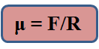
Hence coefficient of limiting friction between any two surfaces in contact is defined as the ratio of the force of limiting friction and normal reaction between them. The value of μ depends on
(i) nature of the surfaces in contact i.e., whether dry or wet; rough or smooth; polished or not polished.
(ii) material of the surfaces in contact.
For example, when two polished metal surfaces are in contact, μ ≈ 0.2, when these surfaces are lubricated, μ ≈ 0.1. Between two smooth wooden surfaces, μ varies between 0.2 and 0.5. Obviously, μ has no units.
When a body is actually moving over the surface of another body, we place F by F_{x}, the kinetic friction, and μ and μ_{k}.
Therefore,
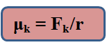
μ_{k} is then called the coefficient of kinetic or dynamic friction. As F_{k} < F, therefore, μ_{k} is always less than μ i.e. coefficient of kinetic or dynamic friction is always less than the coefficient of limiting friction.
Table gives the values of coefficient of limiting/kinetic friction between some pairs of materials:
S.No. | Surface in contact | Coefficient of limiting friction | Coefficient of kinetic friction
1. | Wood on wood | 0.70 | 0.40
2. | Wood on leather | 0.50 | 0.40
3. | Steel on Steel (mild) | 0.74 | 0.57
4. | Steel on Steel (hard) | 0.78 | 0.42
5. | Steel on Steel (greased) | 0.10 | 0.05

Angle of Friction
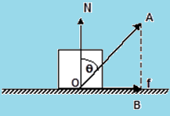
The angle made by the resultant reaction force with the vertical (normal reaction) is known as the angle of the friction.
Now, in the triangle OAB,
AB/OB = cotθ
So, OB = AB/ cotθ
= AB tanθ
Or, tanθ = OB/AB
= f / N
So, tanθ = f / N = µ_{s}

Angle of Repose
It is the angle which an inclined plane makes with the horizontal so that a body placed over it just begins to slide of its own accord.
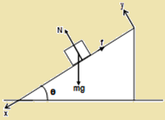Consider a body of mass m resting on an inclined plane of inclination θ . The forces acting on the body are shown – F_{f} being the force of friction. If friction is large enough, the body will not slide down.
Along x: mg sin θ – f = 0
Along y: N –mg cosθ = 0
i.e. N = mg cos θ and f = mg sin θ
Thus, f ≤ µ_{s}N gives,
mg sin θ ≤ µ_{s} mg cosθ
So, tan θ ≤ µ_{s}. This signifies, the coefficient of static friction between the two surfaces, in order that the body doesn’t slide down.
When θ is increased, then tan θ > µ . Thus sliding begins, and the angle θ_{r} = tan⁻¹µ. This angle is known as the angle of repose.

Methods of Reducing Friction
Friction can be reduced if we try to remove the cause of friction.
(a) By rubbing and polishing
(b) By lubricants
(c) By converting sliding into rolling friction
(d) By streamlining
Problem:-
A horizontal bar is used to support a 75-kg object between two walls, as shown in the below figure. The equal forces F exerted by the bar against the walls can be varied by adjusting the length of the bar. Only friction between the ends of the bar and the walls supports the system. The coefficient of static friction between bar and walls is 0.41. Find the minimum value of the forces F for the system to remain at rest.
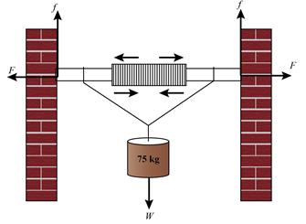
Concept:-
The diagram below shows the forces involved in the system:
The magnitude of frictional force between the walls and the bar is,
f = µ_{s}N
Here µ_{s} is the coefficient of static friction between the walls and the bar , and N is the normal force exerted by the wall on the bar.
If the bar is at rest, the horizontal equilibrium is maintained and the sum of the horizontal forces on the bar must be zero, that is
F – N = 0
F = N
Substitute F = N in equation f = µ_{s}N ,
f = µ_{s}N
=µ_{s} F
To account for the vertical equilibrium of the block, the sum of the vertical forces must be zero,
f + f – W = 0
f + f = W
2f = W
It is important to note that the term on the left hand side of the above equation account for the fact that the frictional force exist at both the ends of the bar and acts in a direction opposite to the direction of weight.
The weight of the block is calculated by multiplying the mass of the block with acceleration due to gravity,
W = mg
Substitute W = mg and f = µ_{s}F in equation 2f = W,
2f = W
2(µ_{s}F) = W
F = mg/2µ_{s}
This equation can be used to calculate the magnitude of force exerted by the bar on the wall that will balance the system.
Solution:-
To calculate the magnitude of force F, substitute 75 kg for m , 9.81 m/s² for g and 0.41 for µ_{s} in equation F = mg/2µ_{s} ,
F = mg/2µ_{s}
= (75 kg) (9.81 m/s²)/2(0.41)
= (897.2 kg.m/s²) (1 N/1 kg.m/s²)
= 897.2 N
Round off to two significant figures,
F= 897.2 N
Therefore, the magnitude of the force exerted by the bar on the wall, to balance the system is 897.2 N

Free Body Diagram

Illustration:
Let us draw FBD for various given systems
[Here we are assuming that all the surfaces strings and pulleys are ideal that is we are neglecting their masses & any friction present]
FBD (1) : Block of mass M is resting on a frictionless rigid surface
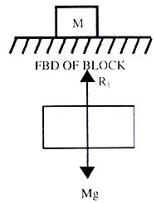
There are only two forces in the system in figure above. mg which is the weight of the block, and is acting on the surface. R2 = mg through its centre (since the body is symmetric). So, here itself from FBD we can see that net external force on the block is zero. That is why, it is stationary on the surface.
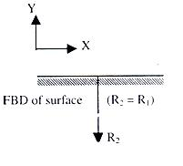
FBD (2) : Draw the free body diagram of the block shown in figure 1.12.
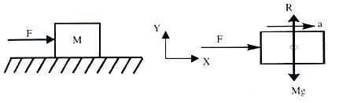
Where R is reaction from the surface (R = Mg)
FBD (3) : Draw free body diagrams of both the blocks (figure 1.13 a), Assuming a reaction of magnitude 'R' is present at the interface.
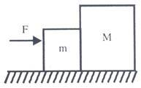
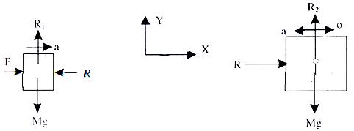
Now a question comes Can 'R' have a direction opposite to what is shown here? Answer is, of course it can have,
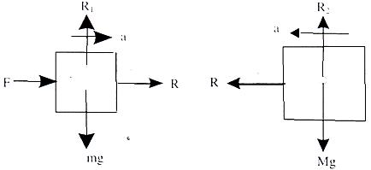
[before we proceed further let me point out that once you make calculations you will find that values of R will automatically come negative, which tells us that earlier direction were the correct ones].
FBD (4) : Suppose situations is as shown in figure above that a light inextensible string pulls a block of mass M on a frictionless rigid surface.
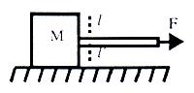
Here string is acting as a force transmitting element
It will experience a tension T in it. Let us cut it (imagine) at then the situation is as shown in figure shown below.
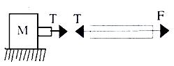
(We join it again then net force should become zero at that point. Since t, and T are oppositely directed their sum will come out to be zero).
So tension t is responsible for dragging mass of block.
Therefore free body representation is
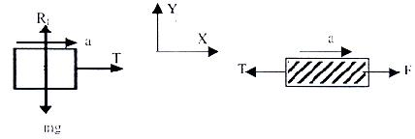
Caution : What happens if rope is not massless?
FBD (5) : Draw free body in case of system shown (figure shown below).
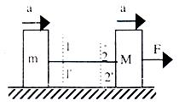
Suppose T is tension in the string, then by cutting it at 1-1' and 2-2' we can draw FBD's as shown in figure shown below.
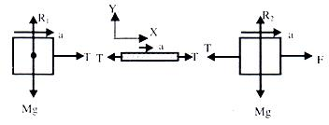
R₁ and R₂ are reactions from plane, and from Newton's law they are equal to the weights of respective blocks.
FBD (6) : Draw FBD where one of the block is resting on an inclined plane and rope goes over a frictionless massless pulley (Figure given below).
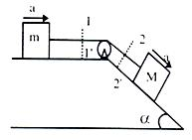
FBD becomes
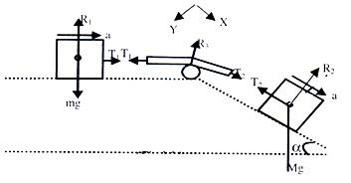
Here the noticeable fact is that R₂ is perpendicular to the inclined plane and mg is perpendicular to horizontal plane. Since Mg is always directed downwards. R₂ is due to the component of Mg, which is acting, perpendicular to inclined plane. (Here, the rule is that reaction force is always normal to the surface, which provides the reaction).
Here for "ease" we can resolve force Mg in two components. One parallel to inclined plane and other on perpendicular to inclined plane. As shown in figure below.
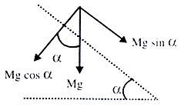
.·. free Body, of the block on the inclined plane can be represented by figure shown below.
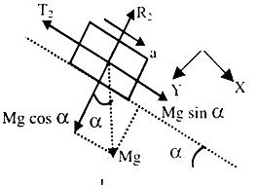
Finally at the end of this FBD, I want to point out that T₂ will always be equal to T₂for a continuous homogeneous massless inextensible string passing over a massless frictionless pulley.
FBD (7) : Suppose both the block are on inclined planes as shown in figure given below.
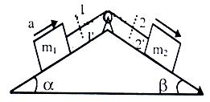
For FBD cut the strings at 1-1' and 2-2' and separate the two blocks and pulleys as subsystems.
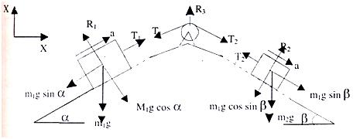
FBD (8) : If pulley is hanging from a rigid support say roof and masses are connected as shown in figure given below.
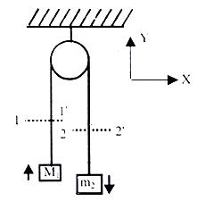
FBD's become.
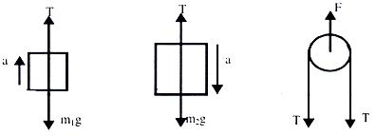
Once we are comfortable in drawing FBD then we can proceed to write equation of motion, using Newton's II Law. But prior to that, it is necessary to briefly introduce you with the concept of equilibrium of bodies.
Equilibrium:
An object is said to be in equilibrium if the vector sum of all the forces acting on the body (externally applied + forces arising due to mutual interaction;) is zero.
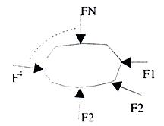
That is 1 + 2 +......+ N = 0
But since it is impractical to apply it, as it is, to problems, therefore we resolve all forces in the three directions X, Y & Z equilibrium and if some of the forces is zero in each direction then the body is said to be in equilibrium. (to be more specific - translator equilibrium).
F_{1x} + F_{2x} + ............ + F_{nx} = 0
F_{1y} + F_{2y} + ............ + F_{ny} = 0
F_{1z} + F_{2z} + ............ + F_{nz} = 0

Enquiry : How to Apply Equations of Motion to Any Problem?
Writing Down Equations of Motion: Once we have made a free body diagram then we can write equations of motion for each part of the system, for which we have drawn FBD. To write down equations of motion for a sub-system for which we have already drawn the FBD the requirement is to choose two direction (if required we will need three directions) in which we shall work to reduce the complexity say, direction X and Y which in most of the cases is natural. In other cases, where we are dealing with inclined planes we can fix our coordinate axis x-y in any desired orientation which reduces our trouble of finding out components of the forces which are acting in various directions and by experience one knows that it is better to choose X axis parallel to the inclined plane and Y axis perpendicular to it. For inclined plane is the right choice of coordinate axis, tilted as per inclination. Now once can go for writing F = ma equations in two directions for any i^{th} sub-system.
∑F_{x} = m_{i}a_{x}
∑F_{y} = m_{i}a_{y}
Let us write down equation of motion for the FBD's we have already drawn.
Refer to FBD (2): Here figure is given below.
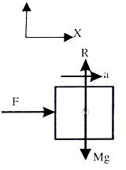
∑F_{y} = R - Mg
It will be zero since we know that on the surface the body can't move upwards or downwards.
.·. R - mg = 0 => R = Mg and ∑F_{x} = F
And this alone should accelerate it
∑ F = Ma, => a = F/m
Refer to FBD (3): Here Figure is given below.
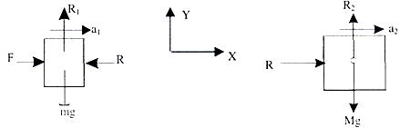
for the smaller block
∑F_{y} = R₁ - mg = 0 .·. R₁ = mg
∑F_{x} = F-R .·. F-R = m a₁
For the Large Block ∑F_{y} = R₂ - Mg = 0 .·. R₂ = Mg
∑F_{x} = R .·. R = Ma₂
Since both Blocks move as on system, their accelerations will be equal
a₁ = a₂ .·. F - R = ma
& R = Ma from here we can solve for R & a.
Refer to FBD (4): Here figure is given below.
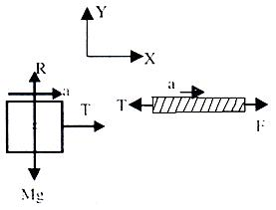
For block
∑F_{y} = R - Mg = 0
.·. R = mg
∑F_{x} = T = Ma
.·. a = T/m
Refer to FBD (5): Here Figure is given below.
Here also, since system is fully connected and we assume that string is not loose, then the acceleration in different parts will be equal. That is, Blocks m and M as well as the string will move with the same acceleration 'a'.
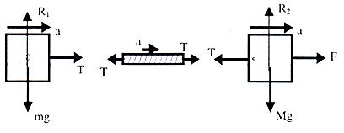
Equation for smaller Block
∑F_{y} = R₁ - mg = 0
.·. R₁ = mg
∑F_{x} = T = ma ............ (1)
For Block - 'M' ∑F_{y} = R₂ - Mg = 0
.·. R₂ = Mg
∑F_{x} = F - T = Ma ......... (ii)
solving (i) & (ii) we get T & a.
Refer to FBD (6): Here Figure is given below.
Since, system is fully connected by light inextensible string therefore acceleration in all the parts will be equal.
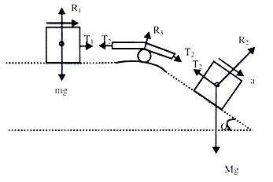
For Block 'm'
R₁ - mg = 0 .·. R₁ = mg
T₁ = ma.
For Block 'M' (Refer to the diagram made with mg cos α & mg sin α components.
R₂ - Mg cos α = 0 (since it is not moving to the plane)
R₂ = Mg cos α and is parallel to the plane
Mg sin α - T₂ = Ma ............ (ii)
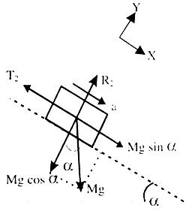
It is already explained that T₁ = T₂ = T
.·. solving (i) & (ii) we get 'T' & 'a' for the system.
Refer to FBD (7) : Here Figure is given below.
T₁ = T₂ = T (similar to the analysis done in FBD (6))
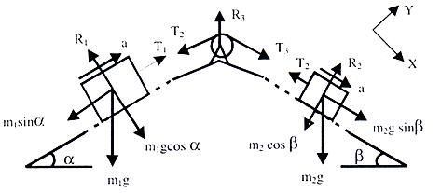
For block m₁ perpendicular to inclined plane T₁ - m₁g cos α = 0 R₁ = m₁g cos α.
Parallel to the plane.
T-m₁g sin α = m₁a ............. (1)
For block m₂ perpendicular to plane
R₂ - m₂g cos β = 0 R₂ = m₂g cos β and m₂ g sin β - T = m₂ a ...... (ii)
Solving (i) & (ii) we get 'a' & 'T.
Refer to FBD (8) : Here Figure is given below.
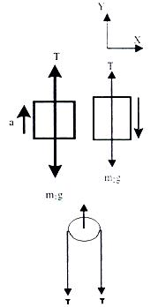
In Y-direction :
For block m₁ T - m₁g = m₁a
For Block m₂ m₂g - T = m₂ a
From (i) & (ii) we can solve for 'T' & 'a'.
On pulley 2T force is acting downwards. Therefore the pulley experiences a force F = 2T. Now you are well conversant with making FBD's and writing down equations of motion for the given system. Therefore, now we can write down some definite steps to follow for any given problem, which can considerably reduce your diversion or confusion or say the possibility of getting trapped into complexity of a problem. (of course for that you have to use your brain all the time with these steps).
(i) Draw the fully connected clear diagram.
(ii) Define subsystems, that is parts of the system on which you will work to get your answers.
(iii) Draw free body diagrams for all possible subsystems.
(iv) Resolve forces as well as accelerations in x y & z direction. (or perpendicular and || to the plane whenever require).
(v) Write, ∑F_{x}, ∑F_{y}, ∑F_{z} equations with the physical constraints appearing in the problem.
(vi) Eliminate some variables and get the required one(s).

Centripetal Force
If a body is moving with a constant speed in a circle, as seen from an inertial frame, it is continuously towards the centre of rotation with magnitude v^{r}/r (known as centripetal acceleration), where v is the speed of the particle and r is the radius of the circular path.
According to Newton's second law, this body will experience net force directed towards the centre called the centripetal force.
Therefore, net force acting on the body towards the centre = mv²/r, where m is mass of body.
Centrifugal force is a pseudo force acting on the body from a rotating frame.
Illustration:
A bob of mass m is suspended form a inextensible, massless describe a horizontal uniform circular motion as shown in figure 1.42. about a vertical. Analyze the dynamics of this system.
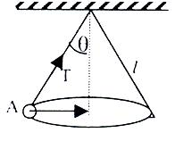
Solution:
The path of the system described above is shown in figure 1.42. Let the radius of circular path of bob is r equal to l sin θ and tension in string is T. The string makes an angle θ with the vertical. Consider the bob is at A. We can draw the free body diagram of bob at a as shown in figure 1.43. The force acting on the bob is it's weight mg and tension T of the string. Tenstion T is resolved in two components T cos θ and T sin θ as shown in figure 1.43. we can write the equation of motion

Banking of Roads
Perhaps you have noticed that when a road is straight, it is horizontal too. However, when a sharp turn comes, the surface of the road does not remain horizontal. This is called banking of the roads.

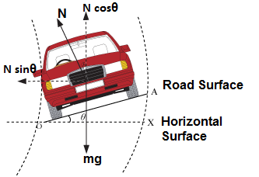

Purpose of Banking
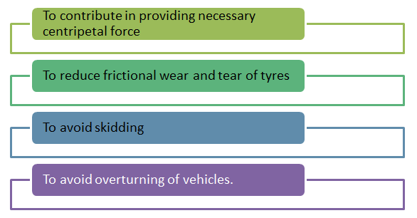
Case I: If coefficient of friction, μ = 0:-
What we really wish is that even if there is no friction between the tyres and the road, yet we should be able to take a round turn. In the given figure Vertical N cos θ component of the normal reaction N will be equal to mg and the horizontal N sin θ component will provide for the necessary centripetal force. [Please note that as we are assuming μ to be zero here, the total reaction of the road will be the normal reaction.] Frictional forces will not act in such a case.
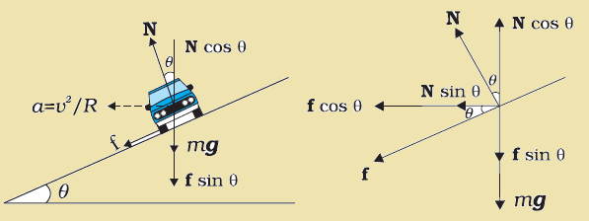
Thus, N cos θ = mg .......... (i)
N sin θ = mv²/r .......... (ii)
Dividing equation (ii) by (i), we get
tan θ = v²/rg
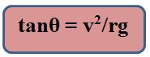
where θ is the angle of banking.
Case - II : If coefficient of friction, μ ≠ 0:-
In the above figure shows a section of the banked road and the view of the vehicle form the rear end.
vehicle-form-the-rear-end
The total forces acting are,
N₁ and N₂ = normal reactions
f₁ and f₂ = frictional forces
mg = weight
r = radius
θ = angle of banking
Let N = Resultant of N₁ and N₂.
f = Resultant of f₁ and f₂.
Let us resolve all the forces horizontally and vertically. As the vehicle has Equilibrium in vertical direction.
so, N cos θ + f sin θ = mg ............ (i)
The resultant of horizontal components i.e., (f cos θ + N sin θ), however, this becomes the net external force acting on the vehicle in the radially inward direction of the round-turn. This thus provides for the necessary centripetal force (mv²/r).
Therefore, f cos θ + N sin θ = mv²/r ............ (ii)
Further, if μ is the coefficient of friction, we have
f = μN ............ (iii)
These are the three basic equations from which, we can find out whatever we want to find out.'
Putting (iii) in (i) gives
N cos θ = μN sin θ + mg
=>N(cos θ - μsin θ) = mg
=> N = mg/cos θ - μsin θ ...............(iv)
Putting (iii) and (iv) in (ii) gives
μ × mgcos θ/(cos θ - μsin θ) + mgsinθ/(cos θ - μsin θ) = mv²/r
=> μ mgr cos θ + mgr sin θ = mv² cos θ - μmv² sin θ
Thus, tan θ = (v² - μrg)/(rg + μv²) ............... (A)
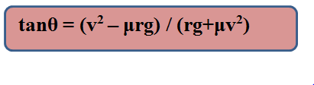
or v² = rg(μ+ tanθ)/(1-μtanθ) ................ (B)
(A) Gives the angle of banking for the maximum velocity v and (B) gives the value of the maximum velocity which the vehicles should be allowed on a road banked at an angle θ.
Notes : 1. The value of μ is the minimum value of μ required. The value of v is the maximum allowable velocity.
Therefore, the best angle of banking θ so that there is absolutely nil wear and tear due to frictional force for the given values of v and r can be determined by putting μ = 0 in this formula.
If we put μ = 0 in formula (A), we get
tan θ = v²/rg
Further, for zero frictional wear and tear, the velocity for the given values of θ and r will be v = √rgtanθ.

Skidding
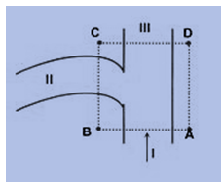
Let us consider the situation in the figure. You are cycling fast on road I. You then want to take a turn to go to road II. However, due to big leak of mobile oil from some truck, the portions of the roads within the area ACBD have become slippery. You do not know about it. You are cycling fast. When you reach the line AC, you turn the handle mounted on the front wheel towards road II. What will happen? Will you be able to take the turn? No, you won't be. Although your front wheel is aligned to go towards road II, you still continue to go straight to road III. This is called skidding. You will skid.
The tendency to slip transverse (transverse means across) to the intended line of run, is called skidding.Thus as soon as you turn the handle of your cycle (or the driving wheel in a motor car), skidding will try to occur. If there is enough friction, this start of skidding brings into action a frictional force between the road and the bottom surface of the wheels of the vehicle. This frictional force then provides for the necessary centripetal force required to negotiate the turn. If friction is not enough, skidding will start which will not let you take the turn in a normal way. Skidding will also cause additional friction wear and tear of the tyres of your vehicle.

How to Avoid Skidding?
Let us consider the situation given in the figure. Let r is the radius of turn which you have to take. N₁ and N₂ are normal reactions mg the weight and F₁, F₂ the frictional forces on the inside and outside wheels.
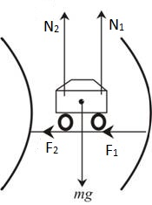
So, (N₁ + N₂) = mg ......... (i)
Thus, F₁ + F₂ = μ(N₁ + N₂) = μgm ......... (ii)
This must be greater than or equal to the centripetal force required.
Therefore, μmg > mv²/r
or, v < √μrg
or, V_{max} = √μrg
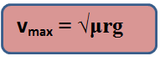
If the velocity of the vehicle is more than √μrg, it will skid.

Overturning
You may have seen overturned trucks lying on the road. Such heavily loaded trucks! Who could have overturned them!! Overturning occurs on the roads when the trucks try to change directions, take sharp turns. Overturning occurs, more after, in case of vehicles which have greater height or whose center of gravity are much high up from the surface of roads.
Let us first consider why over turning would take place at all. Suppose a heavily loaded truck is going straight. Suddenly it takes a sharp turn towards its left. Now what actually happens is that while the upper portion of the truck still tends to go straight because of its inertia (Newton's first law of motion), the lower portion starts going towards left because you have turned the driving wheel accordingly.
Thus, if the inertial forces on the upper portion are much height, they provide so much torque on the truck at its center of gravity that overturning takes place.
Thus overturning always takes place by lifting off the inner wheels from the ground on the curved path.
Limiting case when a four wheeler just begins to overturn on a plain horizontal road:-
Let, Mg = weight
N = Total normal reaction = N₁ + N₂
F = Total friction force
v = velocity
r = radius of the round
2a = distance between inner and outer wheels.
G = center of gravity
h = height of center of gravity from Earth. Frictional force F will provide for the necessary centripetal force.
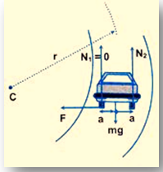
Therefore, F = mv²/r ............... (i)
When the vehicle just begins to overturn, the inner wheels will just begin to lift off from the ground. Their pressure on ground will become zero, so the reaction N₁ on the inner wheels will become zero.
Thus, N₁ = 0
N₁ + N₂ = N₂ = mg
Let us take moments about G
N₂ × a = F × h
Putting (i) and (iii) in (iv) gives
mg × a = mv²/r × h, or v
i.e., v_{max} = √rga/h
If speed goes beyond it, the vehicle will overturn.
Minimum μ required to prevent overturning
We know frictional force is μN.
=> F = μN = μmg ............ (v)
Putting equation (v) in (i) gives
μmg = mv²/r,
Or μ = μ_{min} = v²/rg
F = mv²/r = mω²r
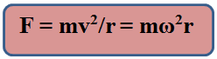
Centripetal force is not a new kind of force. It is the radial component of the net force acting on the particle moving along a circle. Centrifugal force is a type of pseudo force used by an observer moving in a circle. Numerically, it is equal to the centripetal force but is oppositely directed if observer and the body both are moving on same circle as a single unit.

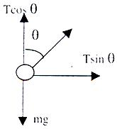
T cos θ = mg T sin θ = mv²/r

